Open the file.
Click Ticks Enabled.
Set Tick Frequency to 8 Hz
Click on the pin labeled X to count up or count down.

Main Circuit
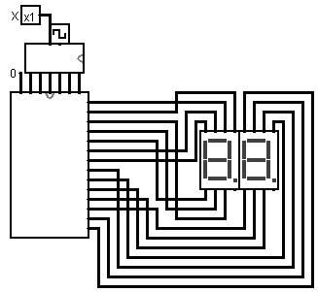

Counter Circuit
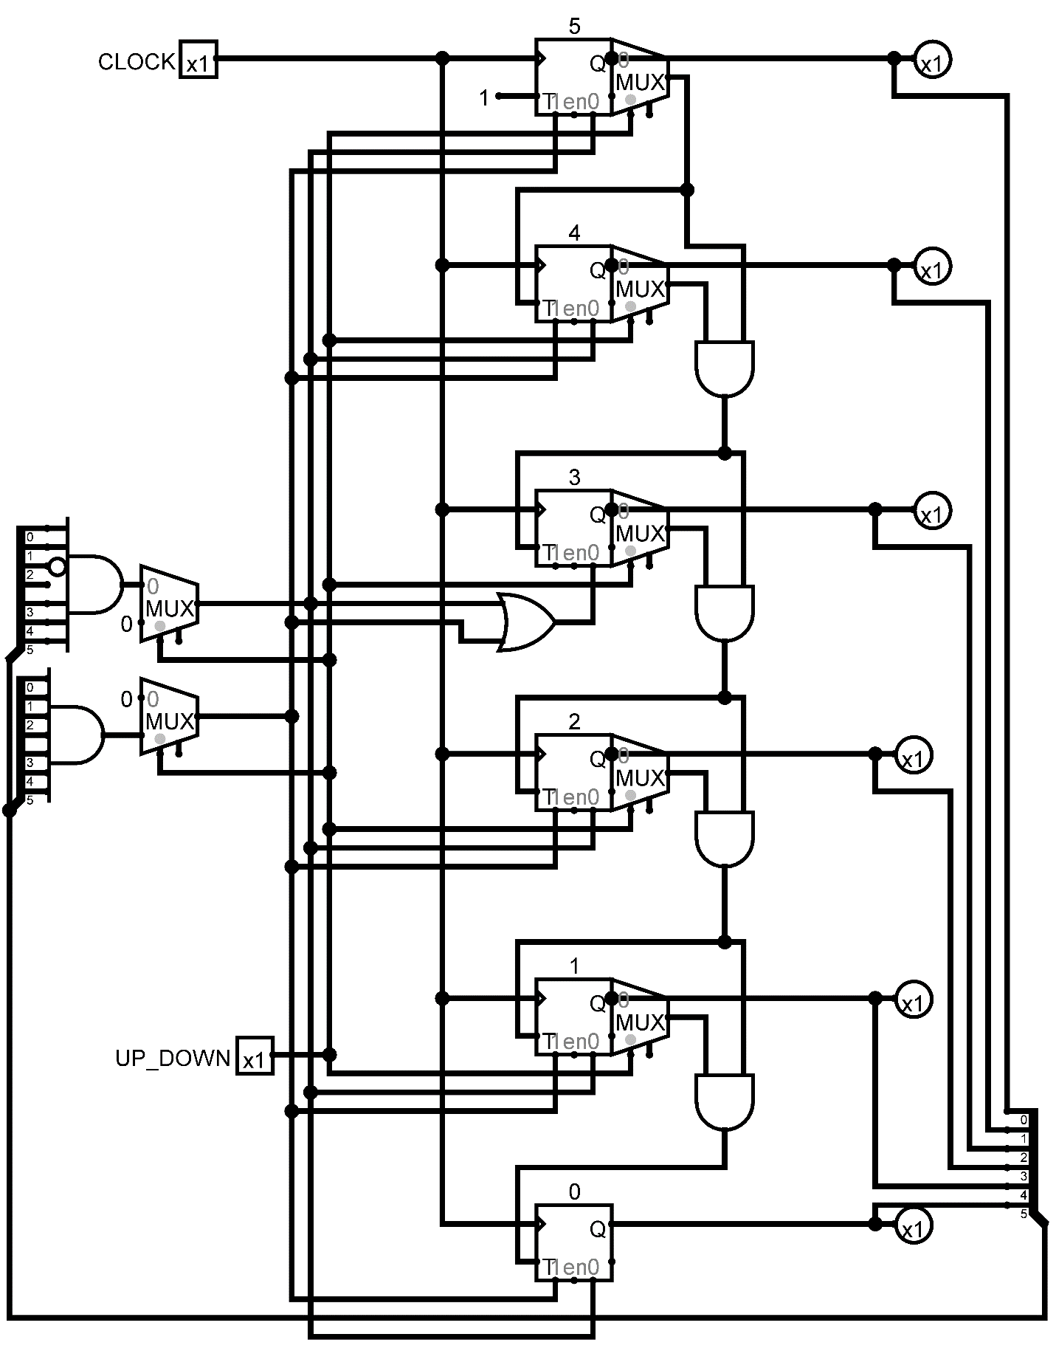

We created a Synchronous counter with only T flip flops, Multiplexers, AND gates and an OR gate.
We set the current output of the system to Q from each T flip flop.
We used the Multiplexers to pick between Q and Q’ to control the next flip flop’s state.
The other 2 multiplexers were used to rest the circuit to 59 or 00 instead of counting up to 63.
We re-used our dual seven segment display driver from Project #1.

